Date: 9/10/2010

To: Tara Smith

Cc: Min Yu, Kijin Knam

From: Yu Zhou

Delta Modeling Section

Bay-Delta Office

Department of Water Resources

Subject : DSM2 version 8 PTM editing, compilation and packaging

This memo presents step-by-step instruction on establishing editable project, compiling and packaging DSM2 (version 8) PTM module in Eclipse. Note this is the version for PTM source code editing purpose. The version for straight compiling is in the DSM2 compiling memo: DSM2_v8_0_Compiling_and_Packaging.

**Required Software and Source Code Check out**

1. Java Development Kit <http://java.sun.com/javase/downloads/index.jsp>
2. Eclipse-jee-galileo-win32 http://www.eclipse.org/downloads/packages/release/galileo/sr2
3. PTM Java source code are checked out in the DSM2 Compile & Package document, with the whole DSM2 coding package:

The specific folder directory on DWR SVN server is:

http://dminfo.water.ca.gov:8686/svn/repository/models/branches/dsm2_v8_0/src/ptm/DWR/DMS/PTM

and could be put at following directory on local computers:

D:\delta\models\dsm2_v8_0\src\ptm\

**Build up project**

**Method 1: with Eclipse project description file**

File -> Import -> Existing Projects into Workspace -> Next -> Select root directory (Browse) to where .project resides -> Ok -> Finish

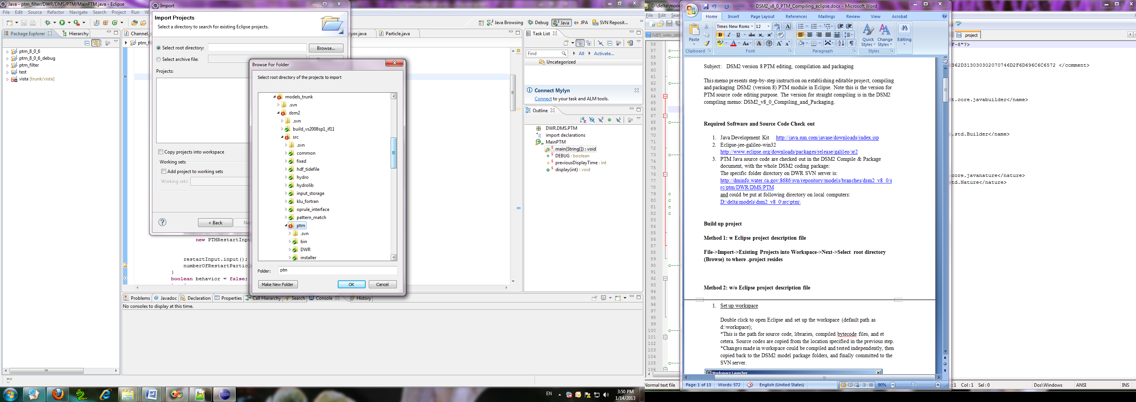

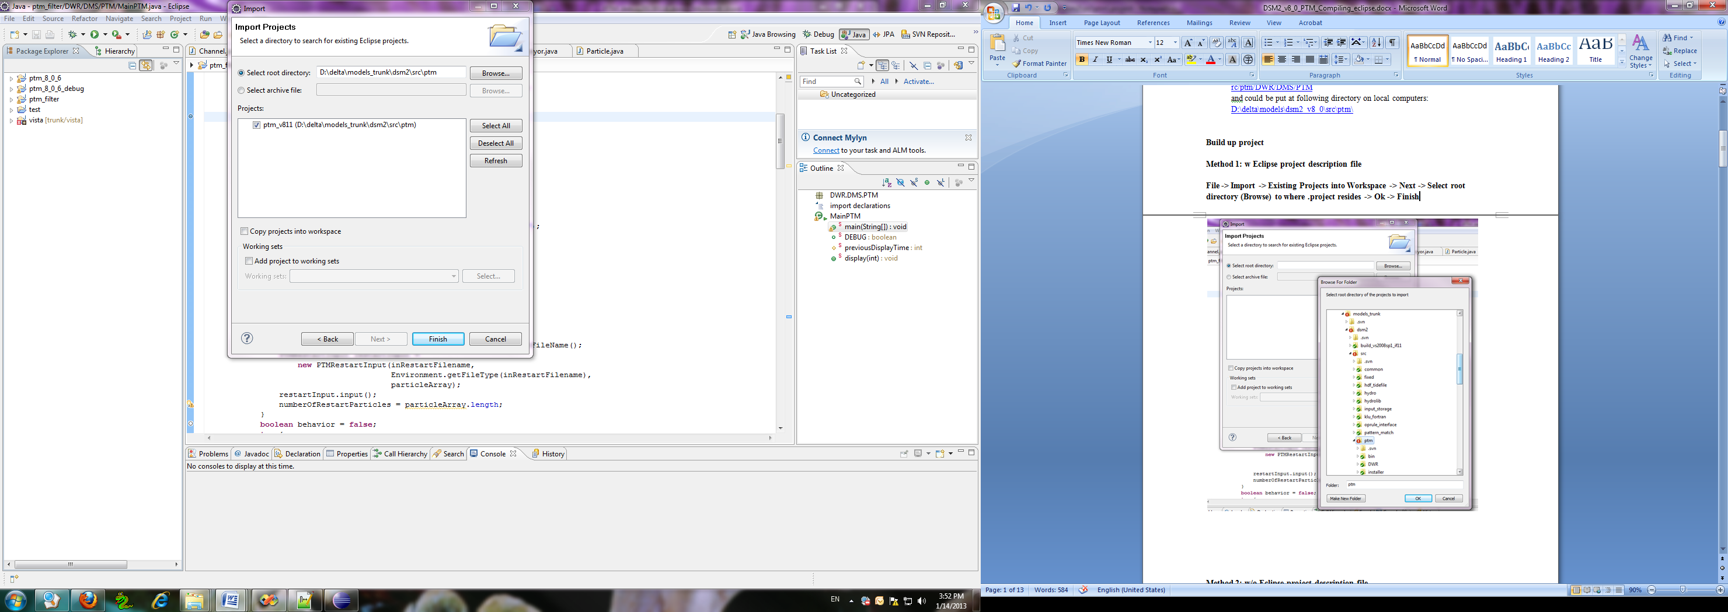

**Method 2: w/o Eclipse project description file**

1. Set up workspace

Double click to open Eclipse and set up the workspace (default path as d:\workspace);

*This is the path for source code, libraries, compiled bytecode files, and et cetera. Source codes are copied from the location specified in the previous step.

*Changes made in workspace could be compiled and tested independently, then copied back to the DSM2 model package folders, and finally committed to the SVN server.

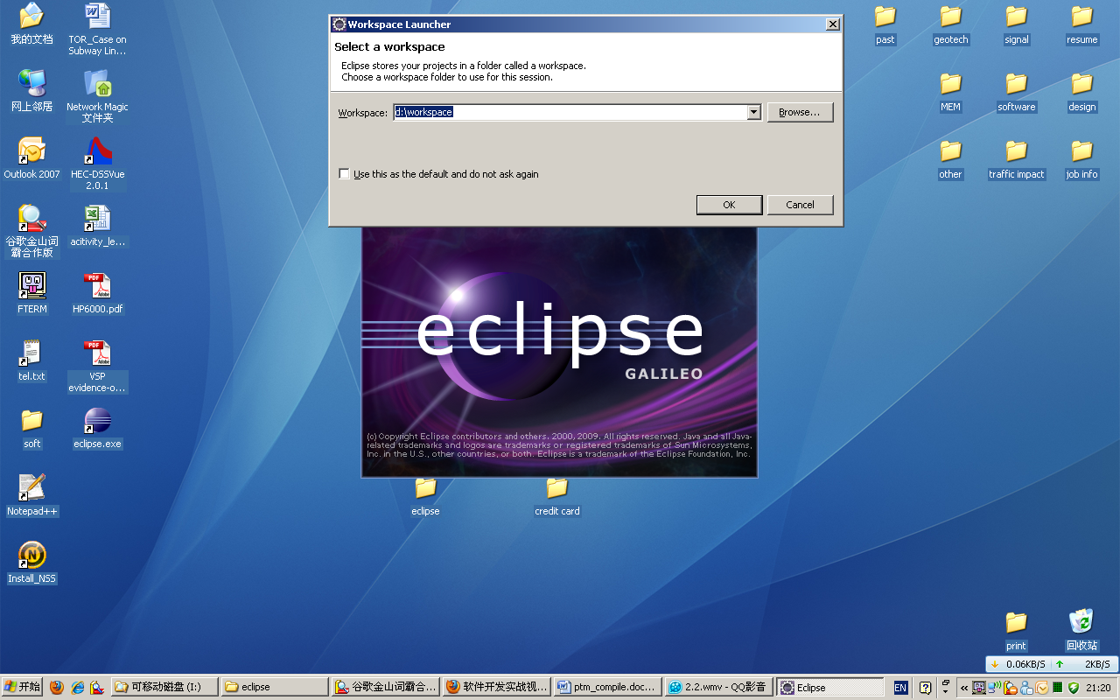

1. Create the PTM project in workspace

File->New->Java Project

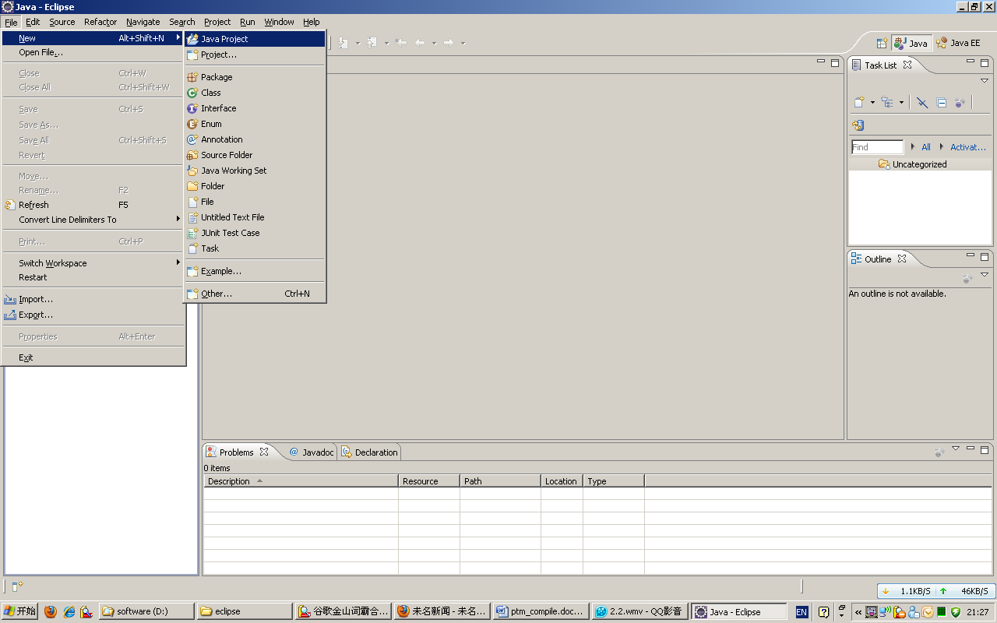

‘Project name’ input e.g. ptm

‘Project layout’ select as ‘Use project folder as root for sources and class files’ (with src and bytecode stored at one place; the other option is also ok for use)

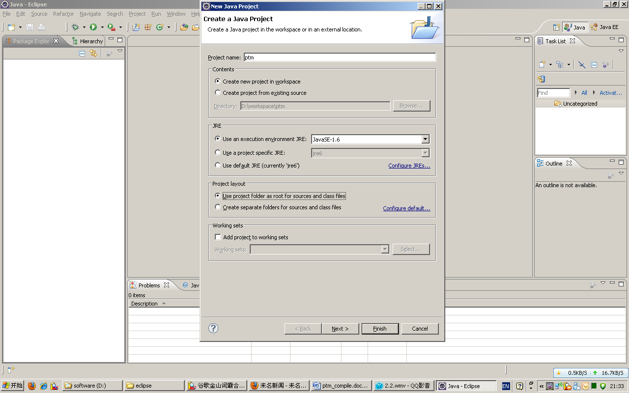

Next->Libraries->Add External JARs->Select 3 jar files (COM.jar, edu.jar, xml.jar) at directory:

D:\delta\models\dsm2_v8_0\src\ptm\lib

Finish

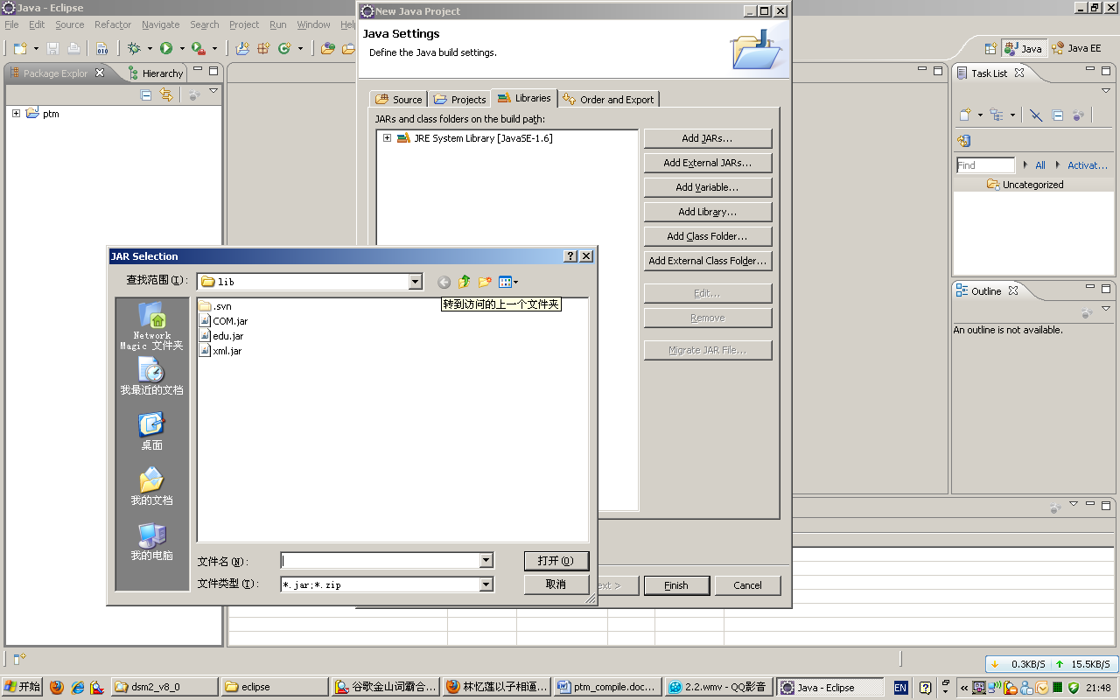

1. Create Package to include source codes:

Right click ptm in the Package Explorer->New->Package

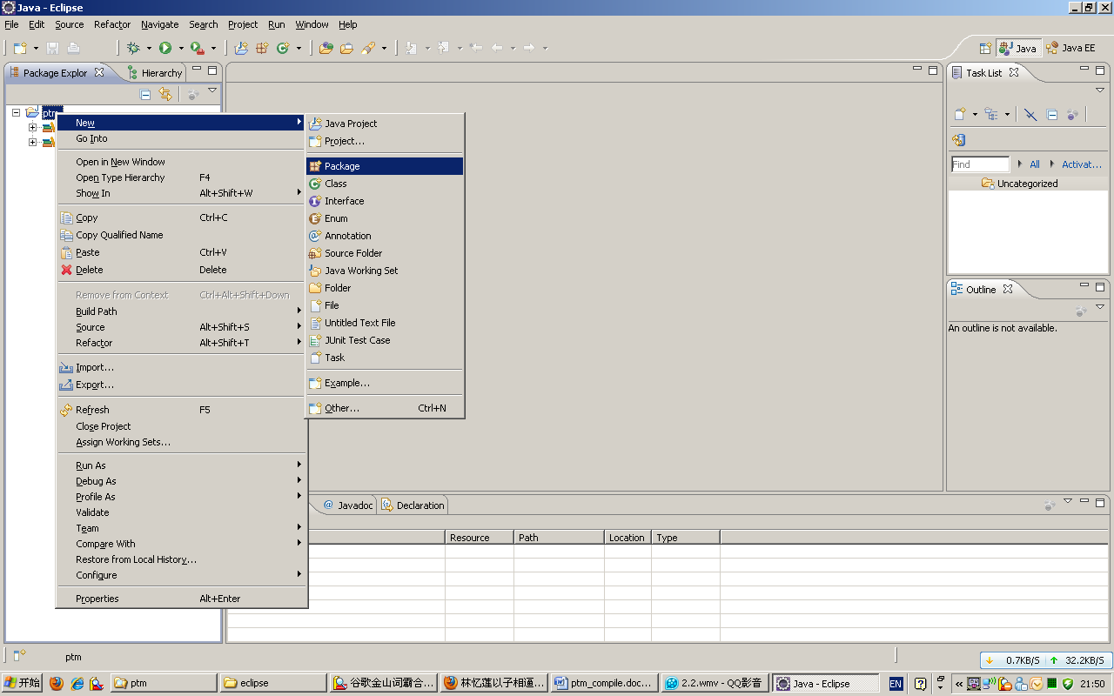

Input Package Name under Source folder ptm: DWR.DMS.PTM

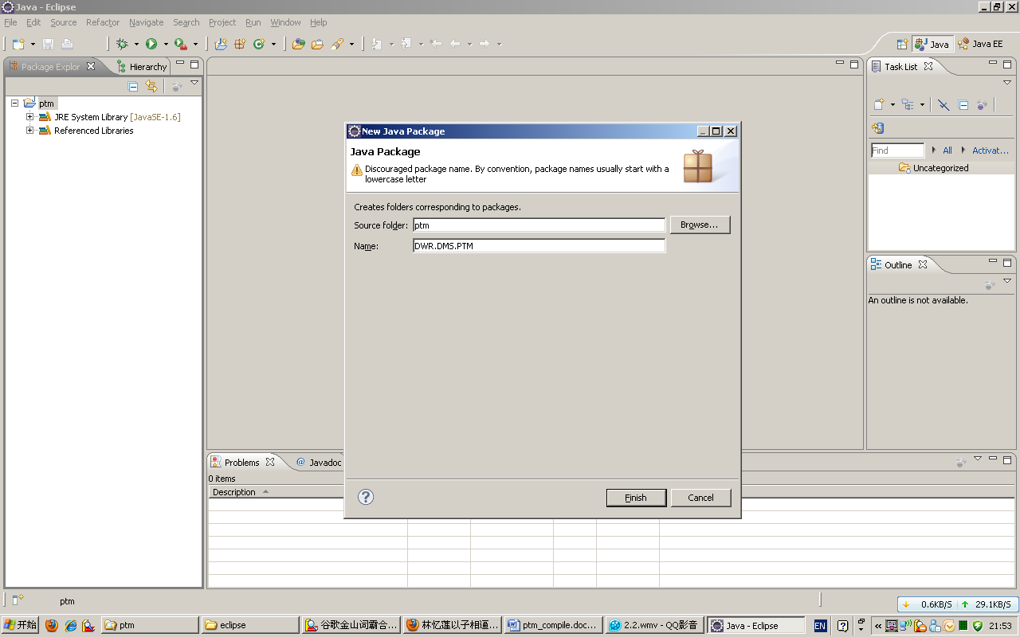

Import java source codes

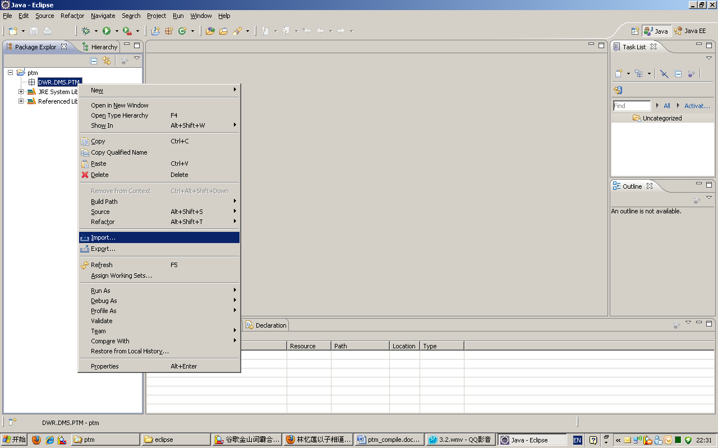

General->File System->Next

From directory->Browse (DSM2 PTM Java src folders) ->OK

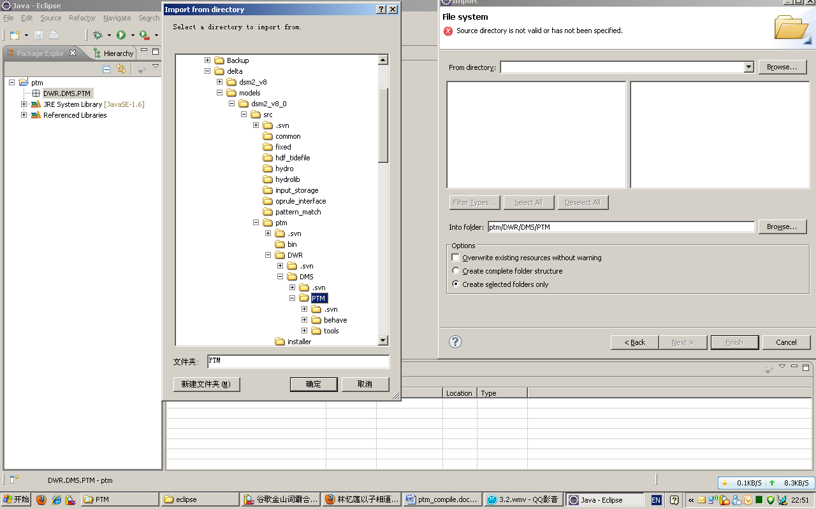

Check PTM box on the left window (to include all the java files)->Finish

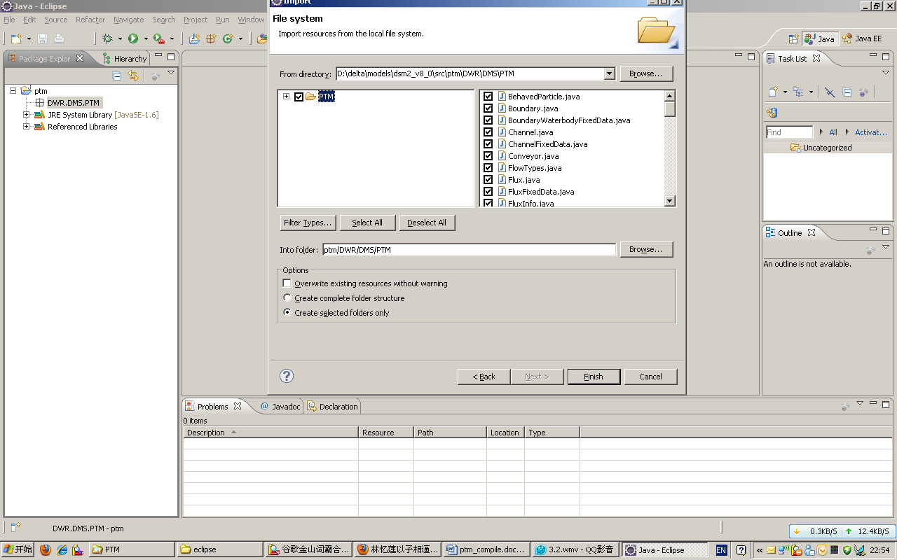

*Eclipse would automatically create 2 packages for the sub-folders:

DWR.DMS.PTM.behave

DWR.DMS.PTM.tools

*If some error msg like ‘access restriction’ comes out: Try to remove the JRE System library from Project ptm->Properties->Java Build Path->Libraries, and add it again

**Compile and debug PTM**

1. Compile source code to bytecode

Project->Build Project

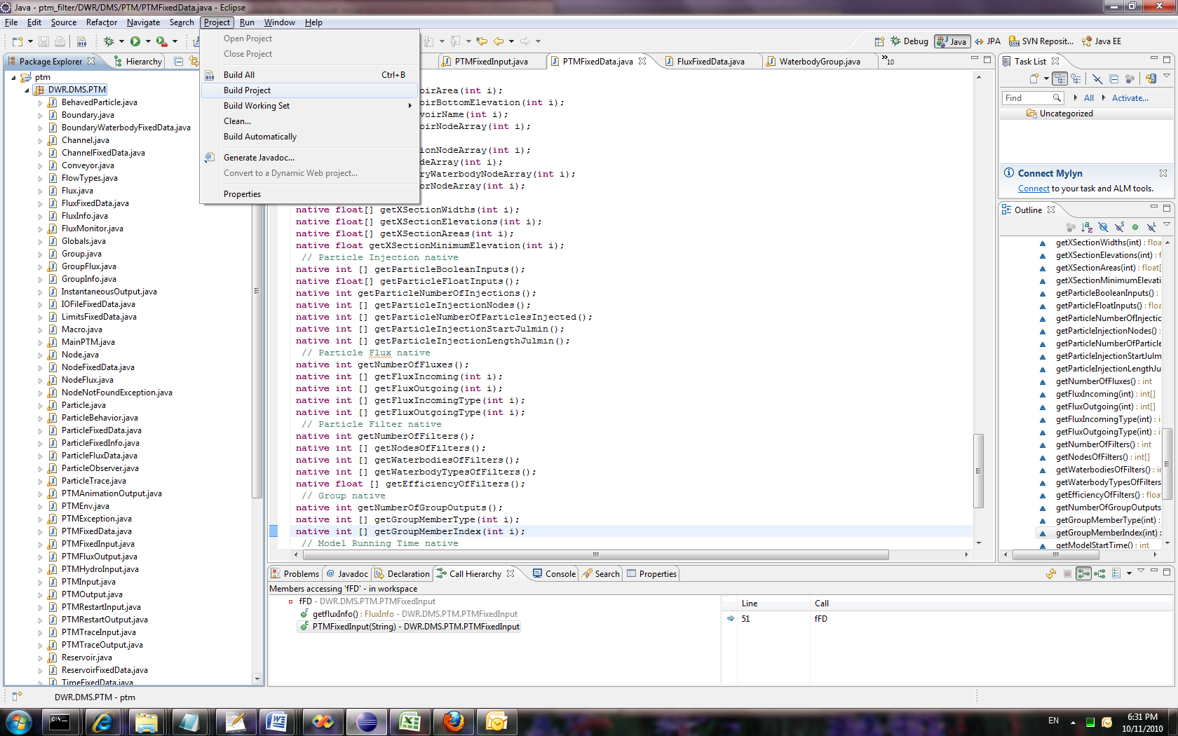

Bytecodes (*.class) are stored at the same place as source codes (*.java)

Automatic compilation could be enabled by Project -> Build Automatically

1. Run/Debug Variables Configuration

Set up the PTM input study file in IDE configuration

Menu Run/Debug-> Run/Debug Configuration

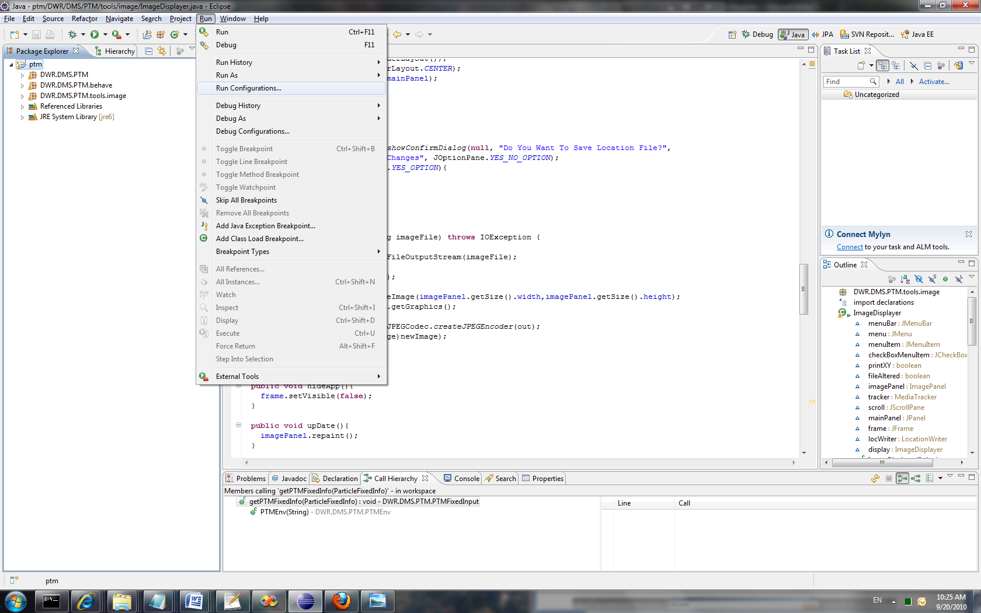

Java Application->New

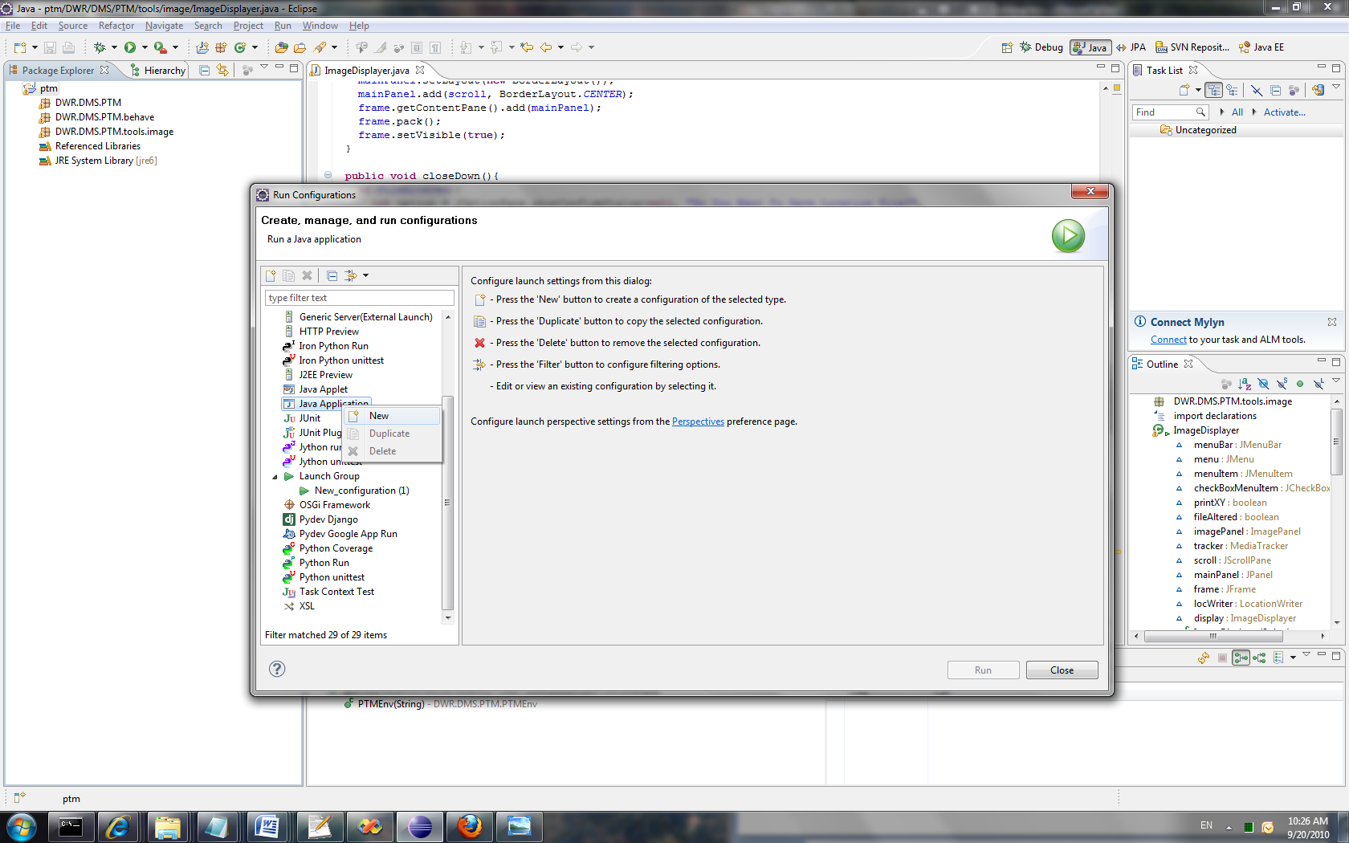

e.g.

Main Tab:

Name: MainPTM

Main Class: DWR.DMS.PTM.MainPTM

Argument Tab:

Program arguments: historical_ptm.inp (the sample PTM input file in a DSM2 v8 historical study; make sure the hydro file has been run first and h5 file exists)

VM arguments: -ss1m -mx512m -oss1m

Other: D:\delta\dsm2_v8\study_templates\historical

Environment Tab:

DSM2_HOME d:\delta\dsm2_v8

Path d:\delta\dsm2_v8\bin

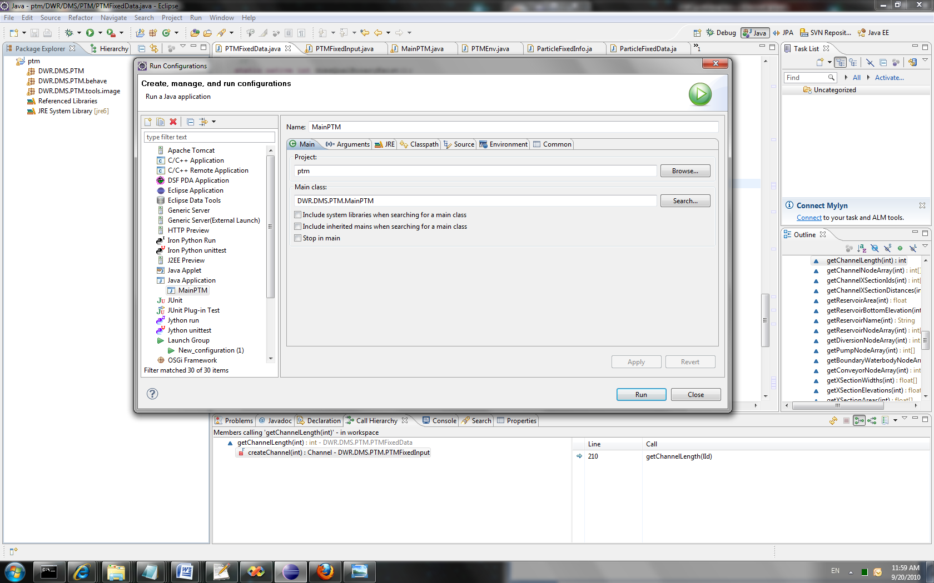

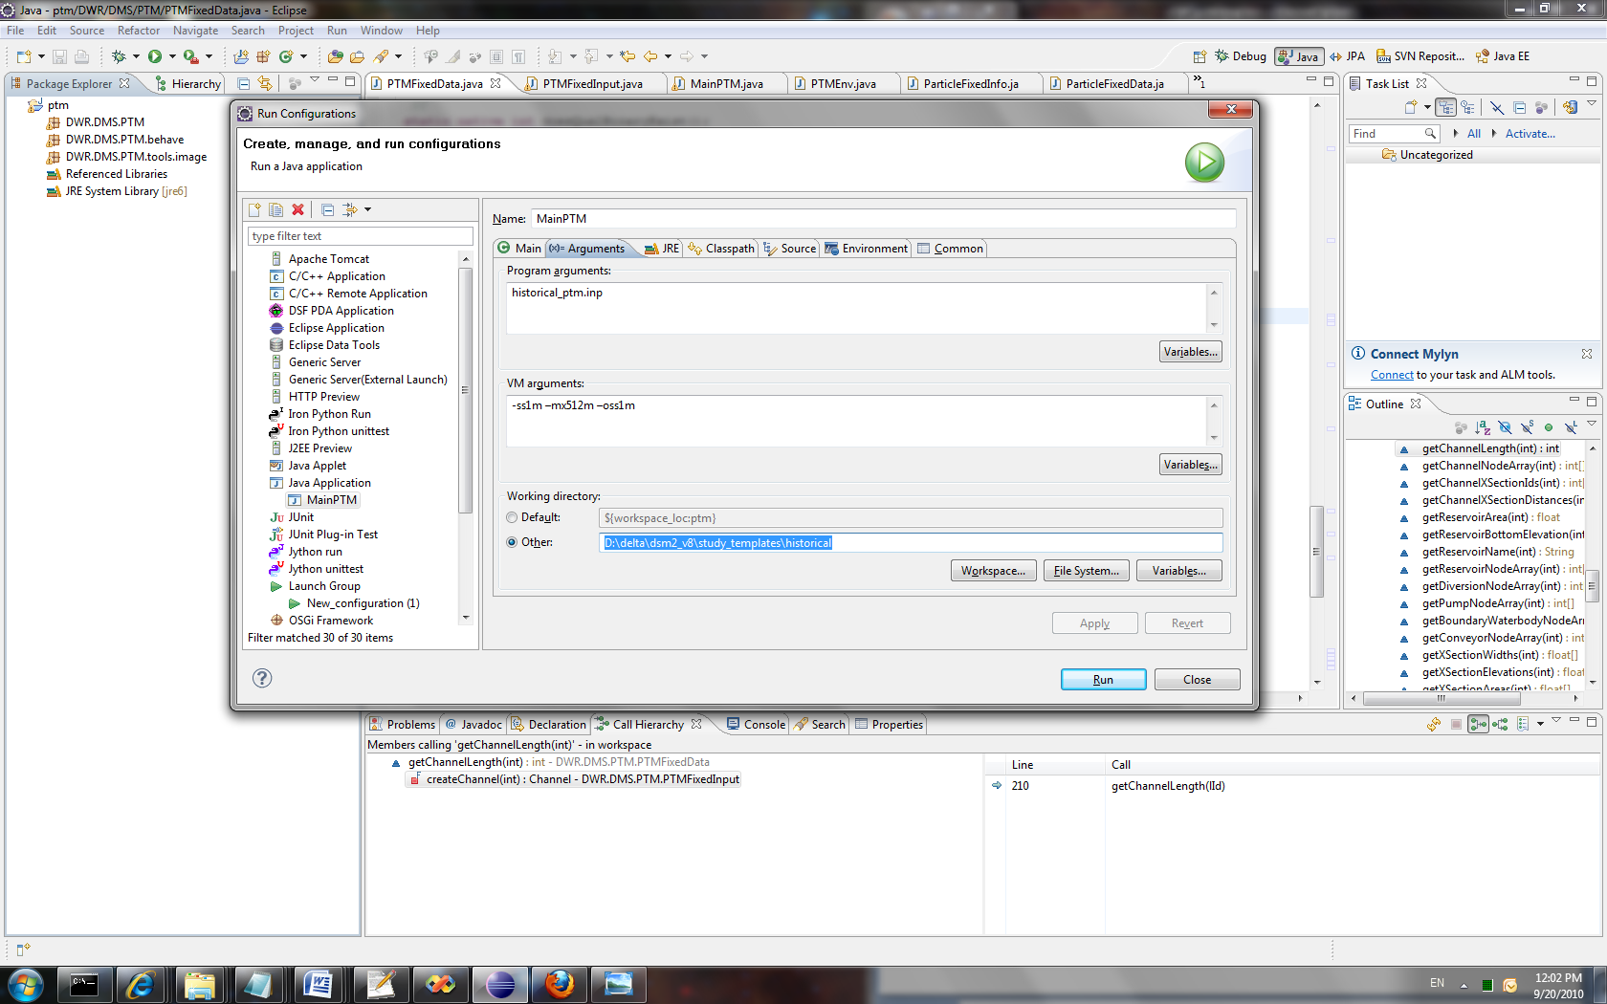

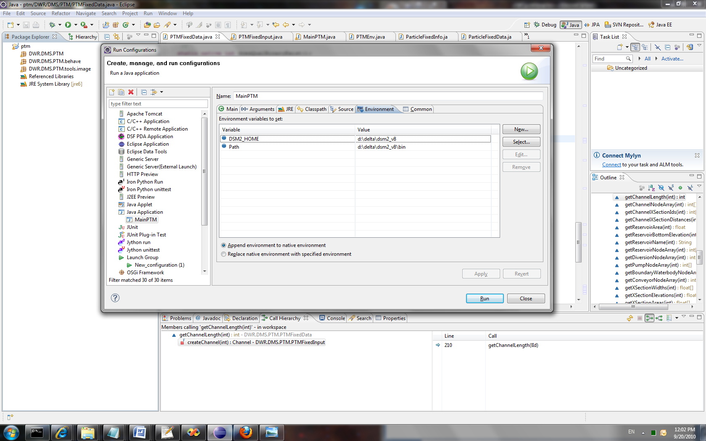

1. Run/Debug PTM

Switch to Debug Mode, which enable breakpoint setting and variable tracking

Run->Run/Debug MainPTM for calculation checking

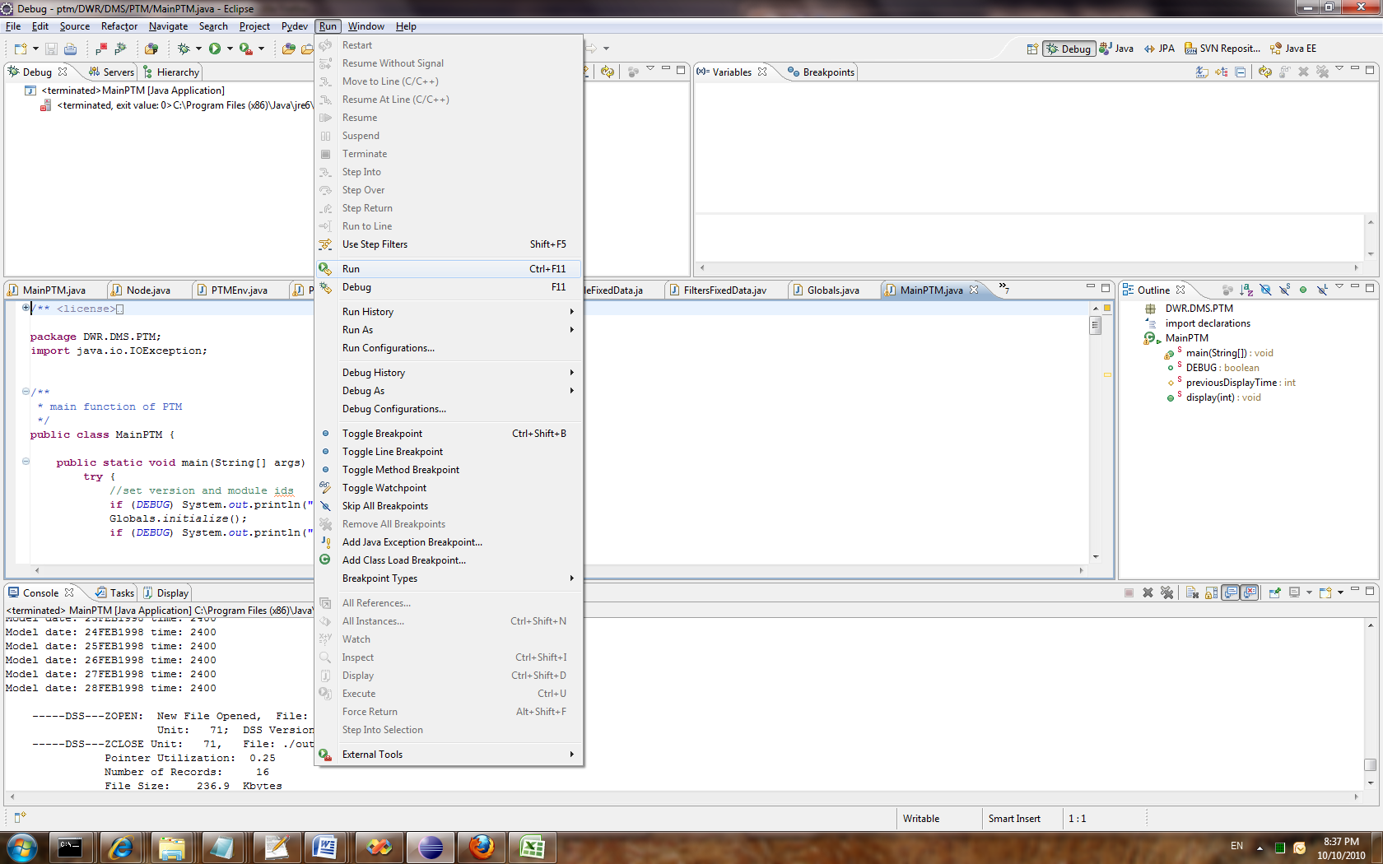

**Export back to DSM2 package**

1. Combine the PTM Java bytecotes and related libraries into a JAR file

File->Export->Java->JAR file

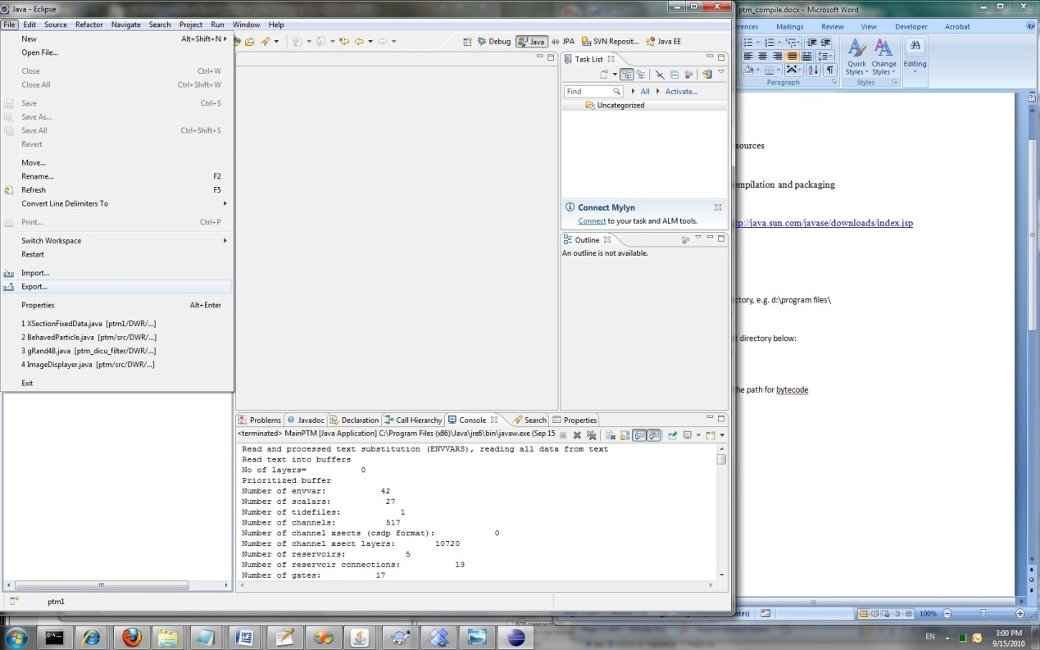

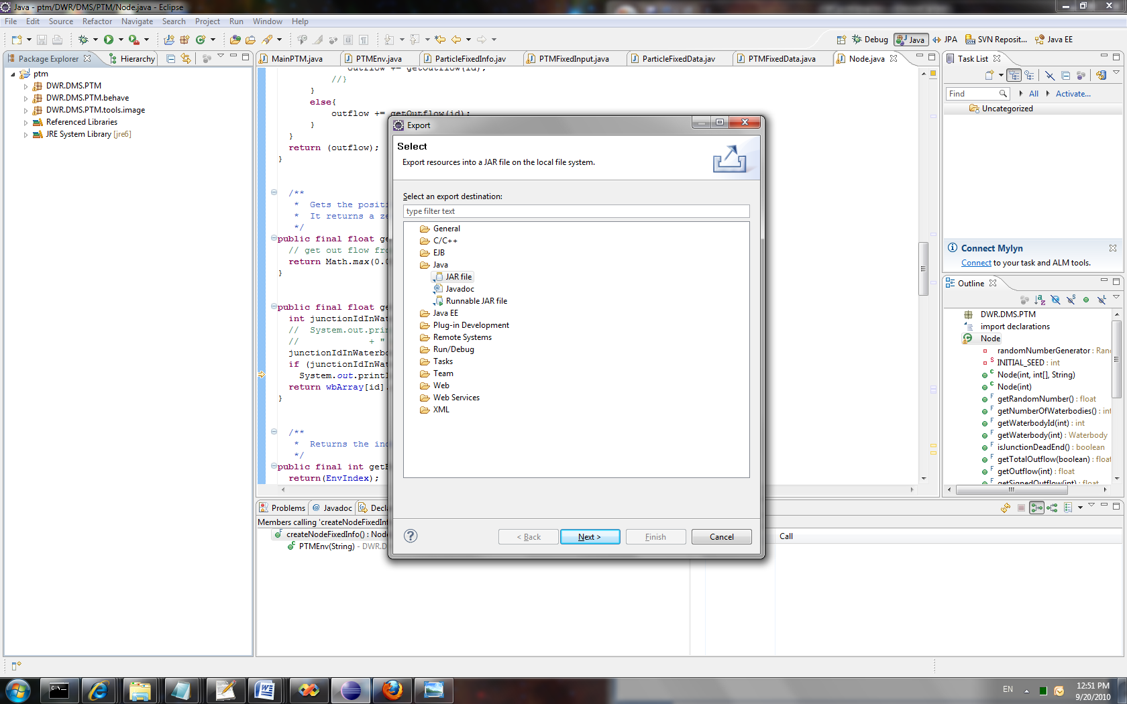

Check ptm box on the left to select all the bytecode files and libraries

Select the export destination: D:\workspace\ptm\ptm.jar

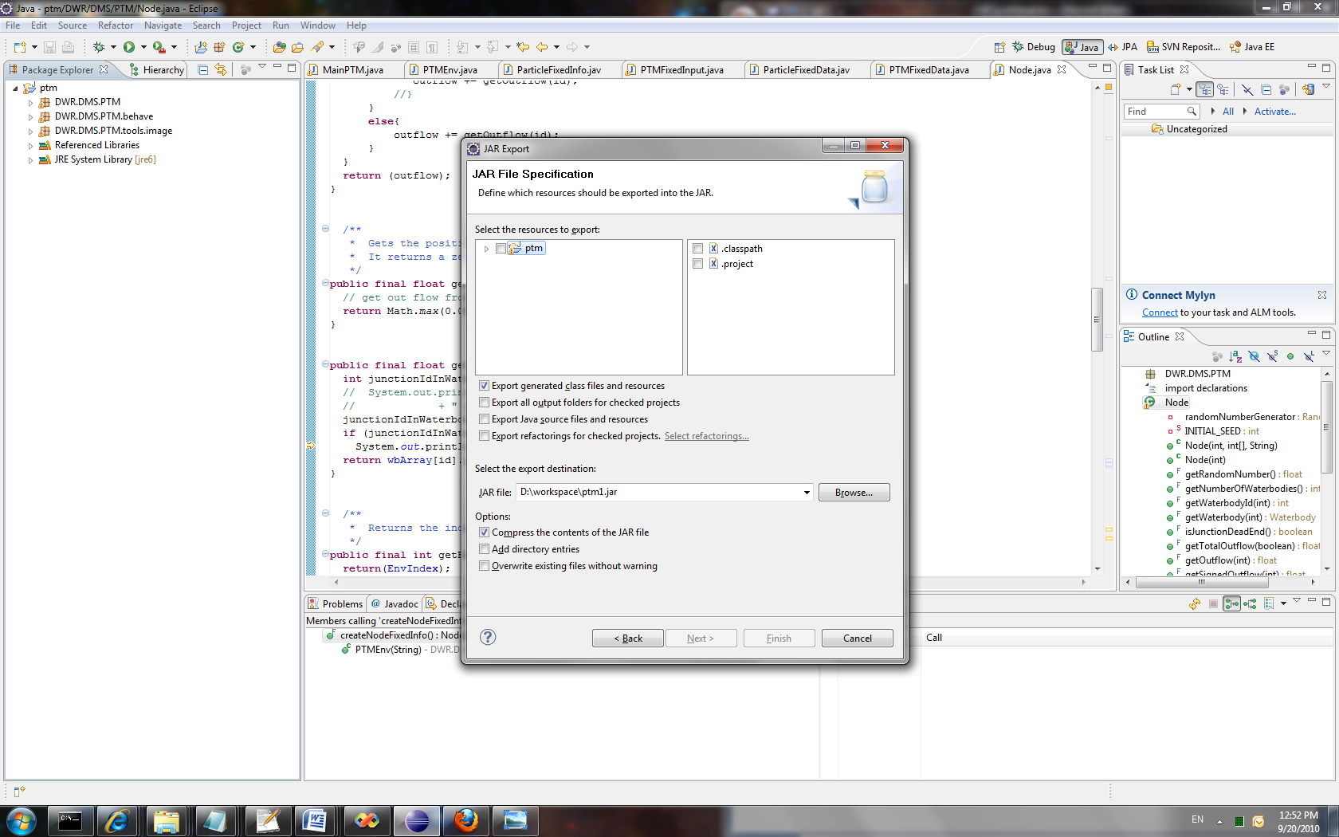

1. Copy the JAR file to the DSM2 distribution binary folder for packaging:

D:\delta\models\dsm2_distribute\dsm2\ptm\lib\

Other PTM related files, e.g. ptm.dll, are compiled in related C++ and Fortran projects of DSM2 Visual Studio solution. Please see the document for details.